Commentaires diapo
Vincent Destailleur

Access to persitent storage
Many real-world Java 2 Platform, Enterprise Edition (J2EE) applications need to use persistent data at some point. For many applications, persistent storage is implemented with different mechanisms, and there are marked differences in the APIs used to access these different persistent storage mechanisms.

Issues : tight-coupling
-create a direct dependency between application code and data access code.
When component like servlets and helper objects for JavaServer Pages (JSP) pages --need to access a data source, they can use the appropriate API to achieve connectivity and manipulate the data source. But including the connectivity and data access code within these components introduces a tight coupling between the components and the data source implementation.
Forces (facteurs qui pousse à l'utilisation du DAO Design pattern)
- Components such as bean-managed entity beans, session beans, servlets, and other objects like helpers for JSP pages need to retrieve and store information from persistent stores and other data sources like legacy systems, B2B, LDAP, and so forth.
- Persistent storage APIs vary depending on the product vendor. Other data sources may have APIs that are nonstandard and/or proprietary. These APIs and their capabilities also vary depending on the type of storage-RDBMS, object-oriented database management system (OODBMS), XML documents, flat files, and so forth. There is a lack of uniform APIs to address the requirements to access such disparate systems.
- Components typically use proprietary APIs to access external and/or legacy systems to retrieve and store data.
- Portability of the components is directly affected when specific access mechanisms and APIs are included in the components.
- Components need to be transparent to the actual persistent store or data source implementation to provide easy migration to different vendor products, different storage types, and different data source types.

Issues 2 : Migration
Such code dependencies in components make it difficult and tedious to migrate the application from one type of data source to another. When the data source changes, the components need to be changed to handle the new type of data source.

Solution : DAO
The DAO manages the connection with the data source to obtain and store data.
The DAO implements the access mechanism required to work with the data source.
Essentially, the DAO acts as an adapter between the component and the data source.

DAO design pattern
The Data Access Object (DAO) design pattern offers a very simple method of mapping Java objects to Databases.
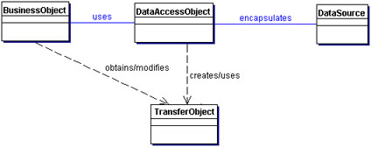

DAO design pattern 2
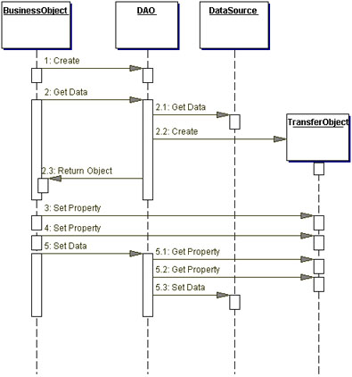

BusinessObject
The BusinessObject represents the data client. It is the object that requires access to the data source to obtain and store data. A BusinessObject may be implemented as a session bean, entity bean, or some other Java object, in addition to a servlet or helper bean that accesses the data source.

DataAccessObject
The DataAccessObject is the primary object of this pattern. The DataAccessObject abstracts the underlying data access implementation for the BusinessObject to enable transparent access to the data source. The BusinessObject also delegates data load and store operations to the DataAccessObject.

DataSource
This represents a data source implementation. A data source could be a database such as an RDBMS, OODBMS, XML repository, flat file system, and so forth. A data source can also be another system (legacy/mainframe), service (B2B service or credit card bureau), or some kind of repository (LDAP).

TransferObject
This represents a Transfer Object used as a data carrier. The DataAccessObject may use a Transfer Object to return data to the client. The DataAccessObject may also receive the data from the client in a Transfer Object to update the data in the data source.
Transfer Object
A DAO uses Transfer Objects to transport data to and from its clients.

Advantages of the DAO design pattern

Designed for distributed architectures.
The DAO approach provides flexibility to change an application's persistence mechanism over time without the need to reengineer : application logic that interacts with the DAO tier. For example, there may be performance benefits in changing an application’s performance mechanism from using Entity Beans to using direct JDBC calls from a session bean, or even a move to an alternative persistence framework, such as Hibernate. Without a DAO tier in place, this sort of transition would require extensive re-engineering of existing code.

Improvement

Factory Method design pattern
When the underlying storage is not subject to change from one implementation to another
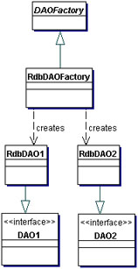

Abstract Factory + Factory Method DP
When the underlying storage is subject to change from one implementation to another,

Abstract Factory + Factory Method DP 2

Consequences
- Enables Transparency
Business objects can use the data source without knowing the specific details of the data source's implementation. Access is transparent because the implementation details are hidden inside the DAO.
- Enables Easier Migration
A layer of DAOs makes it easier for an application to migrate to a different database implementation. The business objects have no knowledge of the underlying data implementation. Thus, the migration involves changes only to the DAO layer. Further, if employing a factory strategy, it is possible to provide a concrete factory implementation for each underlying storage implementation. In this case, migrating to a different storage implementation means providing a new factory implementation to the application.
- Reduces Code Complexity in Business ObjectsBecause the DAOs manage all the data access complexities, it simplifies the code in the business objects and other data clients that use the DAOs. All implementation-related code (such as SQL statements) is contained in the DAO and not in the business object. This improves code readability and development productivity.
- Centralizes All Data Access into a Separate Layer
Because all data access operations are now delegated to the DAOs, the separate data access layer can be viewed as the layer that can isolate the rest of the application from the data access implementation. This centralization makes the application easier to maintain and manage.
- Not Useful for Container-Managed Persistence
Because the EJB container manages entity beans with container-managed persistence (CMP), the container automatically services all persistent storage access. Applications using container-managed entity beans do not need a DAO layer, since the application server transparently provides this functionality. However, DAOs are still useful when a combination of CMP (for entity beans) and BMP (for session beans, servlets) is required.
- Adds Extra Layer
The DAOs create an additional layer of objects between the data client and the data source that need to be designed and implemented to leverage the benefits of this pattern. But the benefit realized by choosing this approach pays off for the additional effort.
- Needs Class Hierarchy Design
When using a factory strategy, the hierarchy of concrete factories and the hierarchy of concrete products produced by the factories need to be designed and implemented. This additional effort needs to be considered if there is sufficient justification warranting such flexibility. This increases the complexity of the design. However, you can choose to implement the factory strategy starting with the Factory Method pattern first, and then move towards the Abstract Factory if necessary.

